
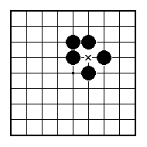
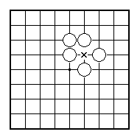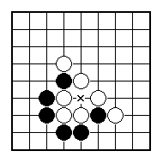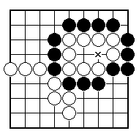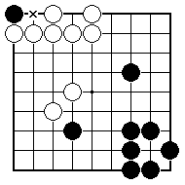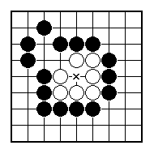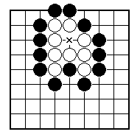
Is Black allowed to play at the place marked x?

Is Black allowed to play at the place marked x?

Is Black allowed to play at the place marked x?

Is Black allowed to play at the place marked x?

Is Black allowed to play at the place marked x?

Is Black allowed to play at the place marked x?

NAME:
BRITISH GO ASSOCIATION CERTIFICATE LEVEL 1 - SHEET 7

THE SUICIDE RULE

